

EDU WAY DESKTOP APPLICATION

Software Develop Competition in

Maris Stella College

2022

RASHITH De SILVA

Contents

Introduction 2

Definition of the problem 2

Project Objective 3

Programming language and tools 3

System Explanation 4

Screenshots 6

My Work 1

Researching and Testing 1

Designing 1

Logo 2

Theming 2

Front end developing 2

Reference 3

# Introduction

Sri Lanka is confronted with a slew of economic issues in the current circumstances. Covid Virus was spreading in the years 2021 and 2020. People’s reactions to the pandemic crisis were varied. When you look at other nations, you will see that they have a plethora of digital platforms to help them complete their everyday tasks. Sri Lanka is a developing country with a growing number of internet outlets. Looking at the software area is likewise evolving. I believe that today is the greatest time to offer new digital products with new features.

First and foremost, I would like to pursue a career in education because I have witnessed several challenges in this subject. Sri Lanka's educational system is among the least developed in the world. If we used an online education system, all the educational institutes would be able to complete their curriculum on time.

There are three key platforms in the software business. There are three types of applications: mobile, desktop, and Mobile. In this period, the United States is primarily attempting to analyze its digital field in comparison to the rest of the globe. In this product, I'll show you how to use a desktop program to manage data in the educational system. The education business, both small and large, has benefited greatly from this arrangement. In Sri Lanka, the majority of people employ a manual data storage approach. However, using this desktop program, all the tasks are completed quickly.

# Definition of the problem

In the previous several years, I have had a lot of educational challenges. The entire educational system has been entrapped. They didn't utilize software to teach before. I enjoy learning new things, but I was unable to complete my previous two-year goals. Looking at the whole students at Ceylon, it appears that someone does not have a sufficient internet connection to educate.

Some students my age is climbing trees to obtain the signal to attend class.

To begin, I must set a goal to establish a management system for problem resolution. Some major educational systems manage their data utilizing an online or digital platform. I am dissatisfied because certain software is very expensive for educational institutions to purchase. I've always thought of and worked on this project as a method to reach out to all types of educational systems, both small and large. There are several drawbacks to utilizing a manual approach for data storage or management. Vital data may be lost. It's difficult to locate the data.

# Project Objective

When I came up with the idea of making this management system. I had a couple of objectives in mind. When I was working more and more on improving EDU way new objectives arise these are some of the main objectives. I need to cut down on the amount of time it takes me to complete this assignment. And they want to cut down on data redundancy. If all the institutes use this type of software, it will be beneficial to their operations.

Using the application, you can add the teacher’s details and student details very easily. Looking into the manual storing database that is not easy for us to store data, but you must chance to store data without hard and with high security.

# Programming language and tools

Programming languages are updated and upgraded regularly. **Java**, **C++,** **C#,** and **Kotlin** are just a few of the most popular programming languages. I have prior expertise with the **C# language**, which was my first language to learn using the OOP concept. The Python programming language was used to create this desktop application. I only had a rudimentary understanding of this programming language before, but now I have a better understanding of

Python. One of the most widely used programming languages is Python. Python has Artificial Intelligence, Machine Learning, and other similar library files. The majority of industrial employees operate in Python, which is a very simple language to understand, similar to our English language.

The EDU way desktop management system, in particular, offered CRUD operations for data storage. This is a well-known process for inserting, deleting, viewing, and updating data.

# System Explanation

**Python** was a programming language that I had created. Before the **log-In** page, I wanted to make a **splash screen**. The code portion of the splash screen faded away over time, and the user was automatically sent to the **log-in** page.

The user interface of the log-in system is shown in the image above. In my opinion, the colors black and blue are complementary to the growth of my project. The admin or primary user must use the right username and password. You will be unable to access the home page if your password or user name is incorrect. 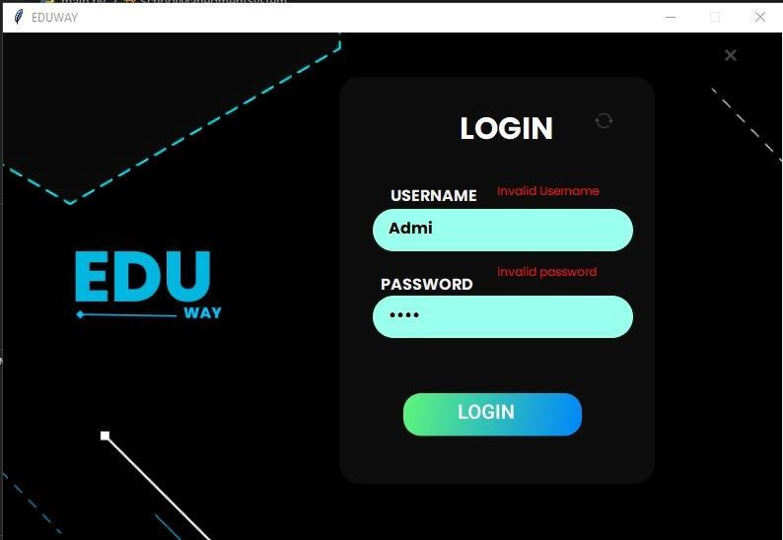

This screenshot depicts the log-in problem that occurs when the password and username are entered incorrectly. I used if statements to cover this section.

If the user enters the proper password, he or she will be sent to the home page, where they may manage their data.

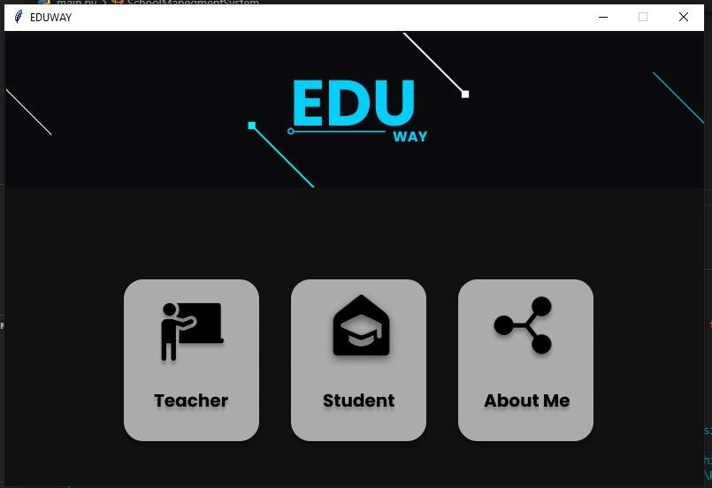

This is a screenshot of the main page, including information on the teacher, student, and me. If a user needs to add a teacher or a student, they can do so by clicking these two buttons. 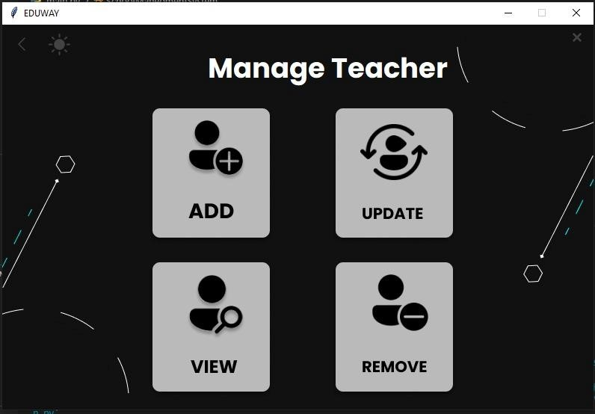

When a person clicks on a teacher, they are given access to manage that instructor. The data has been added to this page. Data may be deleted, viewed, and removed. Some teachers wish to join an education institute where they can readily add students. If an instructor decides to leave the institute, the user has the option of removing him or her. Python makes all of the management processes very simple.

# **Screenshots**

Splash Screen Manage Student

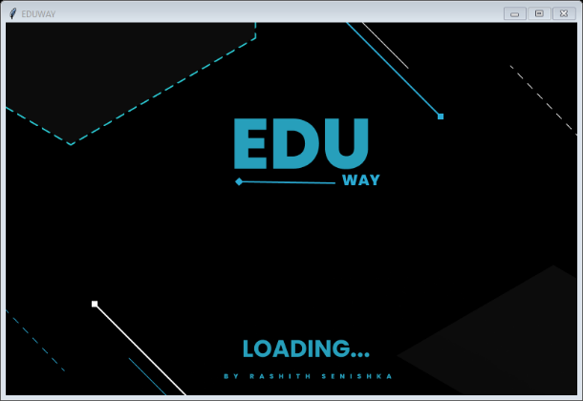 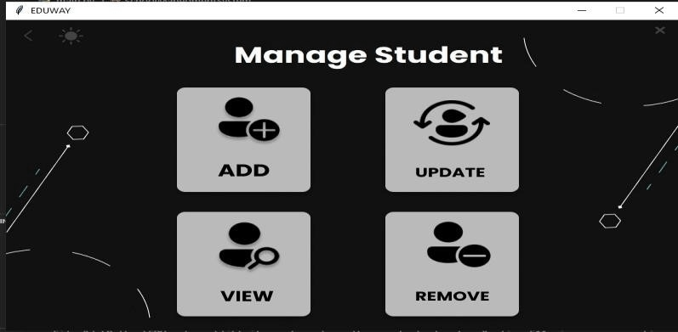

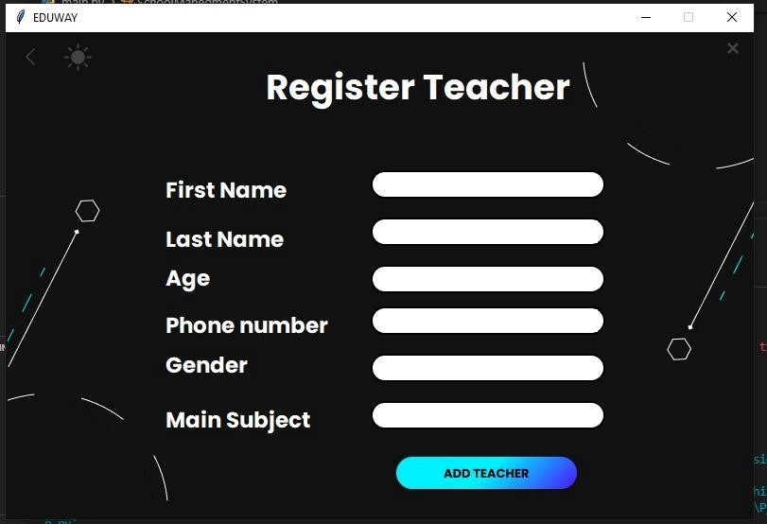 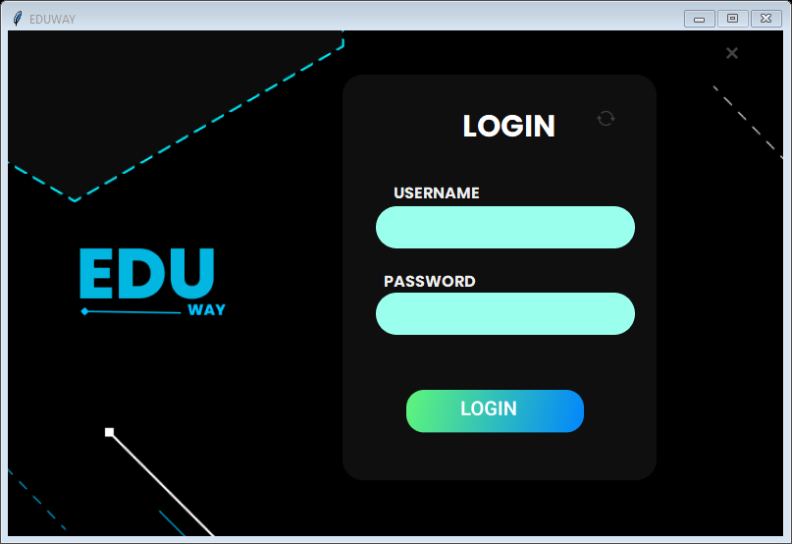

**Teacher Register Login**

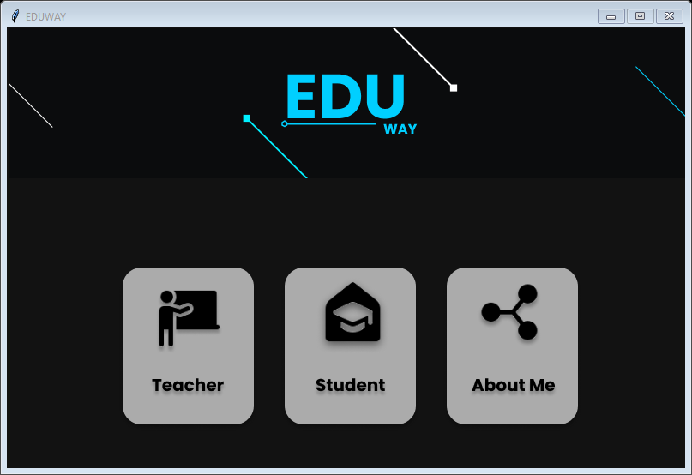 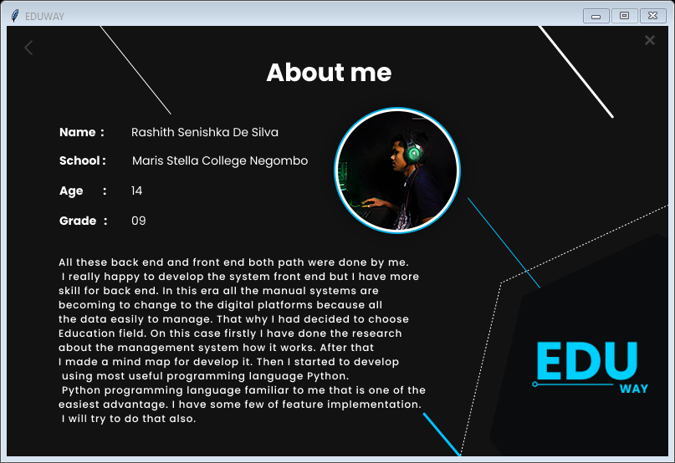

**Home About Me**

# My Work

In my spare time, I like coding. It is beneficial to me to expand my technological skills in a pandemic situation. During that time, I participated in a variety of social IT activities. I also learned several fundamental programming languages such as C#, Java, and Python. One of my primary tasks for participation in a competition is this one. I looked at several social media channels to get an idea of how to go about setting up this management system.

Name: Rashith De Silva

Age:14 years

Grade: Grade 9 (Turn into grade 10)

# Researching and Testing

I spent 5 days on my research mainly focused on creating a project using only using in build tools in python so I search for tools I can use for this project I found an article on google scholar that helped me to find the right tool. after finding the tools I watch a tutorial on YouTube [**1**][**3**]

After I watched a video [**2**] to find how to do simple crud operations in python after finding it I watched a video[**4**] to find how to create a database in the **xampp** server. after finding it I spend some time learning **Figma** to design **UI[6].**inbeginning,Istarted to write code in **netbien** **pycharm** **IDE** but after I reached 100 lines I used **visual studio code** code editor for codding because its easier than using **pycharm** **IDE** for mange

# C:\Users\Rashith Senishka\Downloads\Documents\download (2).jpgDesigning

The designing process is easier than coding for me because I’m working as a graphic designer for a few years. I used **Figma[7]** to design the **UI.**

The reason I used Figma for the designing is that Figma memory usage is less than other tools like adobe xd, adobe photoshop, illustrator, etc.

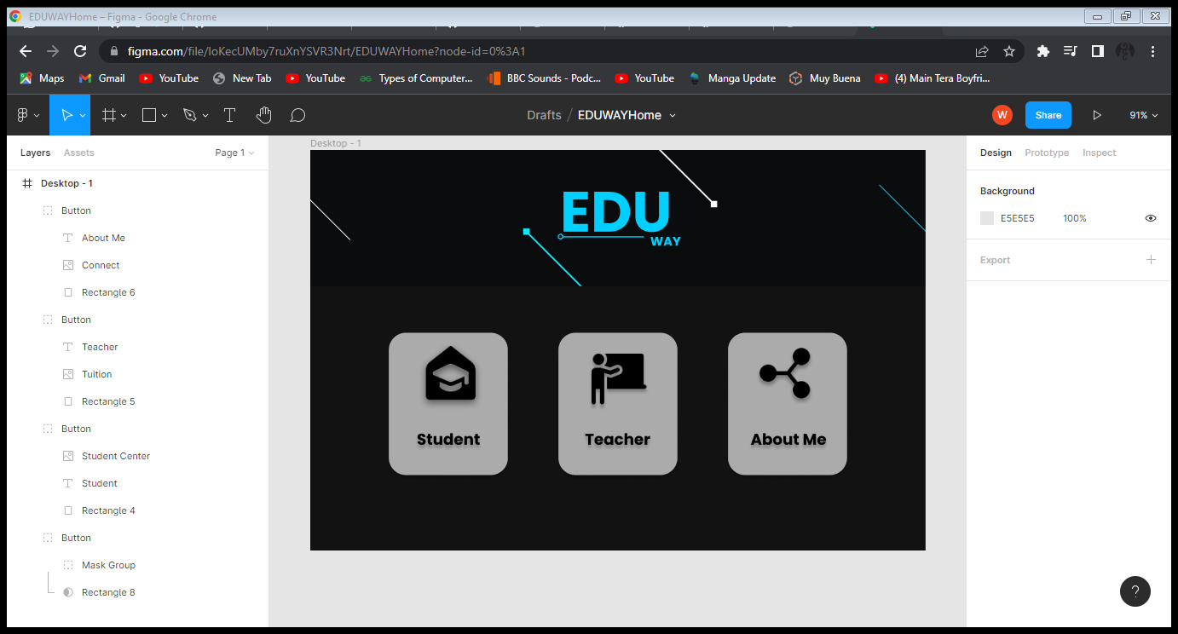

# C:\Users\Rashith Senishka\Downloads\Documents\download (1).pngLogo

# I created a simple lettermark logo for this software using adobe illustrator. The reason I used Illustrator [8] is better for creating logos.it manipulates raster graphics better than other software.

# Theming

C:\Users\Rashith Senishka\AppData\Local\Microsoft\Windows\INetCache\Content.Word\LightThemeimg.png

I create a button to change the theme of the software. The user can change the theme according to user choice

# Front end developing

I created frontend using **Tkinter** which is an in-build tool in python. **Tkinter** is not a rich **GUI** package for **UI** development. I used **PNGs** to make the **UI** better. The reason I use PNG it is better than **jpeg [9].**

# Reference

1: <https://www.youtube.com/playlist?list=PLQVvvaa0QuDclKx-QpC9wntnURXVJqLyk> :this is the main video that helped me to create my project structure.it helped me to create the main project classes and other **GUI** s.

2: <https://youtu.be/Jpf_G1D3TlE>:I learn how to do **crud** operations in **Tkinter** from this video And applied it to my project.

3:<https://youtu.be/YTqDYmfccQU>:after following this video I learn how to create a table for this project. I created a table in student view and teacher view.

4:<https://youtu.be/WmFHreVid-k>: I learned **Xampp** server in this video.

5:<https://youtu.be/ELkaEpN29PU>:I used this video to learn **Tkinter** basics.

6:<https://youtu.be/FK4YusHIIj0>:I learn how to use **Figma** to design my user interface (**UI)**

7. <https://www.figma.com/>

8. <https://www.adobe.com/products/illustrator.html>

9.<http://www.differencebetween.net/technology/protocols-formats/difference-between-jpg-and-png/>